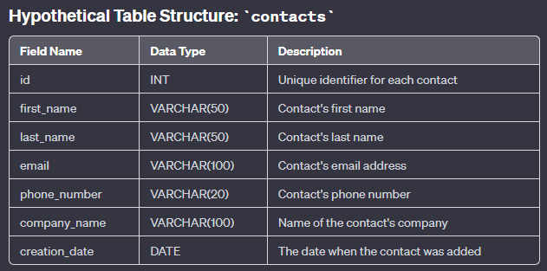

1. Look for all contacts first name starts with A
SELECT *
FROM contacts c
WHERE c.first_name LIKE 'A%';
This will get all columns from the contacts table, but only show contacts whose first name starts with the letter A.
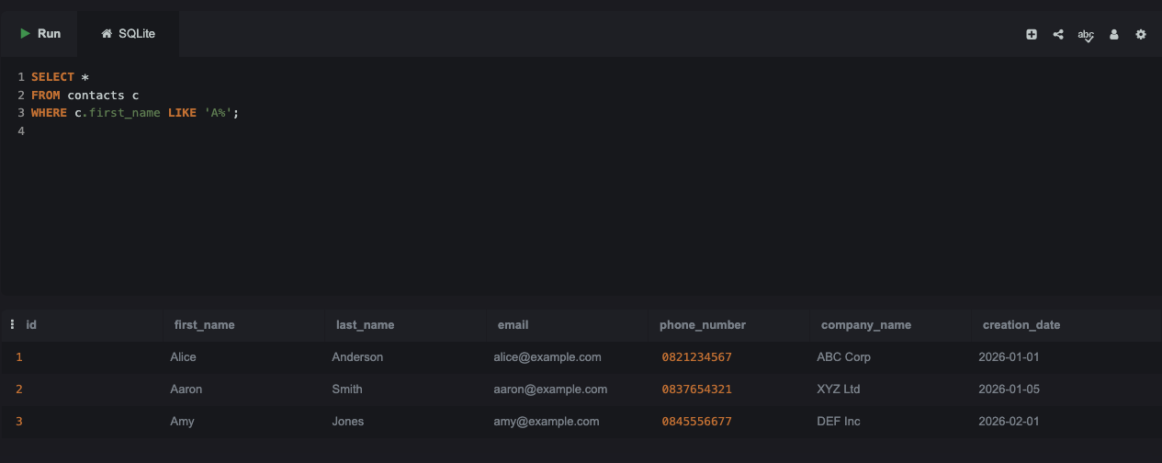
2. find contacts who have a note added in last 7 days
SELECT *
FROM contacts c
INNER JOIN contact_notes n ON n.contact_id = c.id
WHERE n.created_at >= DATE('now', '-7 days');
Find all contacts who have had at least one note added in the last 7 days.
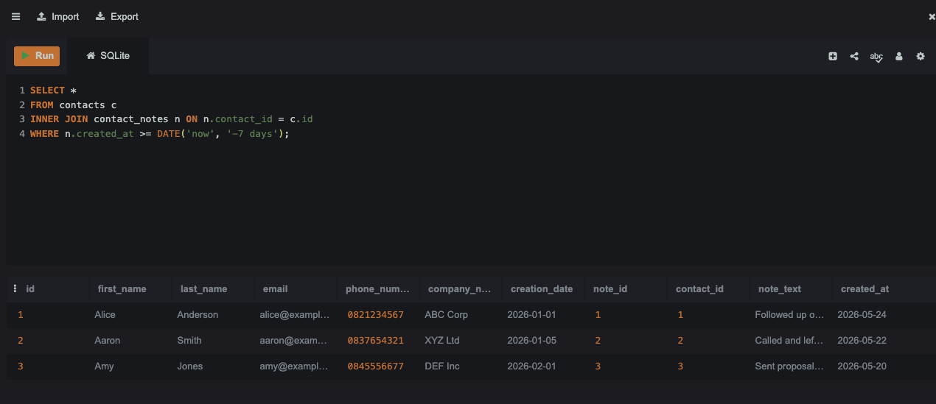
3. Pull the full name, email address and most recent note for each contact
SELECT
CONCAT(c.first_name, ' ', c.last_name) AS full_name,
c.email AS email_address,
n.note_text AS most_recent_note
FROM contacts c
INNER JOIN contact_notes n ON n.contact_id = c.id
WHERE n.created_at = (
SELECT MAX(n2.created_at)
FROM contact_notes n2
WHERE n2.contact_id = c.id
);

This query will pull the full name, email address and most recent note for each contact.
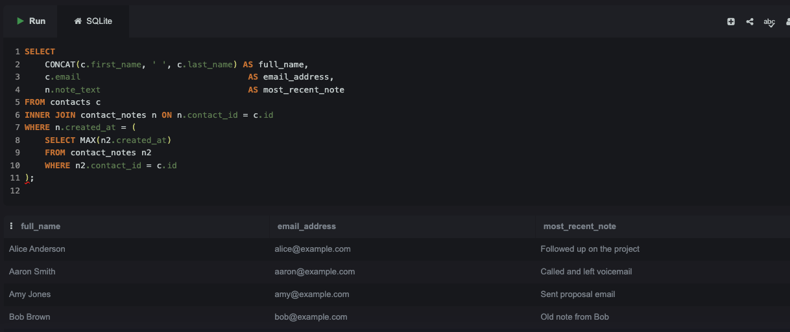
4.
Write a joint statement to extract the above information.
Which means — combine all 3 requirements into one single SQL query that returns:
- ✅ Full Name
- ✅ Email Address
- ✅ Most Recent Note Text
SELECT
CONCAT(c.first_name, ' ', c.last_name) AS full_name,
c.email AS email_address,
n.note_text AS most_recent_note
FROM contacts c
INNER JOIN contact_notes n ON n.contact_id = c.id
WHERE c.first_name LIKE 'A%'
AND n.created_at >= DATE('now', '-7 days')
AND n.created_at = (
SELECT MAX(n2.created_at)
FROM contact_notes n2
WHERE n2.contact_id = c.id
AND n2.created_at >= DATE('now', '-7 days')
)
ORDER BY full_name;

This query will pull the full name, email address and most recent note for all contacts whose first name starts with A and who have had at least one note added in the last 7 days

